

**The Graduation Project :-**

|  |  |  |
| --- | --- | --- |
| **القسم** | **الإسم** |  |
| **علوم الحاسب لائحة جديدة** | **عبدالرحمن محمد رامى عبدالسلام** | **1** |
| **علوم الحاسب لائحة جديدة** | **فادى عزمى ابراهيم عزيز** | **2** |
| **علوم الحاسب لائحة جديدة** | **محمد عبدالحميد حسين عبود** | **3** |
| **علوم الحاسب لائحة جديدة** | **احمد ممدوح محمود محمد** | **4** |
| **علوم الحاسب لائحة جديدة** | **بلال سباء لمعى محمد** | **5** |
| **علوم الحاسب لائحة جديدة** | **على عدلى عبدالظاهر احمد** | **6** |
| **علوم الحاسب لائحة جديدة** | **عمر عصام الدين حنيش يونس** | **7** |
| **علوم الحاسب لائحة جديدة** | **محمد ابراهيم حمدان لاشين** | **8** |

**• Students List:-**

**Assistant: Eng. Shaimaa Mahmoud**

**Supervised by: Dr. Mahmoud Elshishtawy**

**Project No: 8ـــ Project Code: N42208 ـــ Academic Year:2021/2022**

**ABSTRACT**

In a rapidly changing business environment, it’s very important to be able to respond to client needs in more effective and timely manner. If your customers wish to see your business online and have instant access to your products or services. Today online shopping (Multi-Vendor Shop Site) is a lifestyle, which retails various fashion and lifestyle products (Currently Wear). in this project customers are allowed to view various products available, enabled to be registered to purchase desired products instantly using payment method (Instant Pay) and also can place order by using Cash on Delivery (Paying Later) option. Also, this project provides an easy contact to the Administration and management to view orders placed using Pay Later and Instant Pay options. For developing an ecommerce website, there are some Technologies must be studied and understood. For example, these technologies must include multi-tiered architecture, server and client-side scripting techniques, implementation language such as PHP (Laravel Framework) and relational databases. In this project, the main objective is to implement basic website where a consumer is provided with a shopping cart application and also to know about the technologies used to develop such an application. In this document we will discuss each stage to create and implement an ecommerce website.

**ACKNOWLEDGEMENTS**

The process of expressing emotions at this very difficult time, I would like to be very grateful for what the city of culture and science has given us, but that is impossible.

It has given us all the essentials of computer science and information systems, so I would like to express my thanks and gratitude for them staff and assistants.

In the beginning, we did a lot of work on that project, but it's nothing compared to what Dr. Mahmoud Elshishtawy did.

He has been of assistance to us throughout all phases of the project, and without his guidance, we would not have completed it. Also I am very thankful for her continuous feedback and encouragement throughout this project work. His broad knowledge and hardworking attitude has left me with very deep impressions and they will greatly benefit me throughout my life.

I'd also like to highlight the great role played by the Eng. Shaimaa Mahmoud Through her instructions throughout all phases of project implementation and her contributions to solving most of the problems that have arisen for us in the process of completing that project.

**Table of Contents**

**ABSTRACT ........................................................................................................** 2

**ACKNOWLEDGEMENTS ....................................................................................** 3

**Chapter 1: INTRODUCTION .............................................................................** 8

* 1. Overview: .......................................................................................................... 9
     1. Advantages of System: ............................................................................. 9
     2. Disadvantages of System: ....................................................................... 12
  2. Services provided by the System: ...................................................................... 15
  3. Background Information: .................................................................................. 17
  4. Problem Statement: .......................................................................................... 18

**Chapter 2:** **Theoretical Background and Tools...............................................** 19

2.1 The Frontend: .................................................................................................. 20

2.1.1 HTML5: .................................................................................................. 20

2.1.1.1 Advantages of HTML5? ............................................................... 20

2.1.1.2 Disadvantages of HTML5? .......................................................... 21

2.1.2 CSS3: ..................................................................................................... 21

2.1.2.1 Advantages of CSS3? ................................................................. 21

* + - 1. Disadvantages of CSS3? ......................................................... 22

2.1.3 Bootstrap: ............................................................................................... 22

2.1.3.1 Why Bootstrap? ......................................................................... 23

2.1.3.2 Advantages of Bootstrap? ........................................................... 23

2.1.3.3 Disadvantages of Bootstrap? ....................................................... 24

2.2 The Backend/Server: ........................................................................................... 24

2.2.1 PHP: ....................................................................................................... 25

2.2.1.1 Why PHP? ................................................................................. 25

2.2.1.2 Advantages of PHP? ................................................................... 26

2.2.2 Laravel Framework: .................................................................................. 27

2.2.2.1 Why Laravel? ............................................................................. 28

2.2.2.2 Advantages of Laravel? .............................................................. 28

2.2.2.3 Disadvantages of Laravel? .......................................................... 29

2.3 The Database: ..................................................................................................... 30

2.3.1 MySQL: ................................................................................................... 31

2.3.1.1 Why MySQL? ............................................................................. 31

2.3.1.2 Advantages of MySQL? ............................................................... 32

**Chapter 3:** **System Analysis & Design: ...........................................................** 33

3.1 Software Requirement Specifications (SRS):- …………………………………………… 34

3.1.1 Purpose: ........................................................................................ 34

3.1.2 Project Scope: ................................................................................ 34

3.1.3 Functional Requirements: ................................................................ 34

3.1.4 Non-Functional Requirements: ......................................................... 35

3.3.5 Performance Requirements: ............................................................ 35

3.3.6 Interface Requirement: ................................................................... 35

3.3.7 Software Interface: ......................................................................... 35

3.3.8 Hardware Interface: ........................................................................ 35

3.2 System Design:- ........................................................................................ 36

3.2.1 ER Diagram: ...................................................................................... 36

3.2.2 Use Case Diagram: ............................................................................ 37

3.2.3 Sequence Diagram: ............................................................................ 39

3.2.4 Activity Diagram: ............................................................................... 40

**Chapter 4:** **SSL (Secure Sockets Layer): ……………………………...……………** 44

4.1 SSL (Secure Sockets Layer): ........................................................................

4.2 Importance of SSL: .....................................................................................

4.3 How it Work: ..............................................................................................

4.4 Advantages of SSL: .....................................................................................

4.5 Disadvantages of SSL: .................................................................................

4.6 SSL Goals: ..................................................................................................

4.7 What is SSL encryption? ...............................................................................

4.8 Security in Our project: ................................................................................

4.8.1 Security Algorithm: ...........................................................................

4.8.2 Algorithms we have chosen: ..............................................................

4.8.2.1 RC: .....................................................................................

4 4.8.2.2 DBS: ................................................................................

4.8.2.3 Hashing: .............................................................................

**Chapter 5:** **Website Implementation: ...............................................................**

5.1 Front End Layouts: .........................................................................................

5.1.1 Home Layout: ................................................................................

5.1.2 Login Layout: ................................................................................

5.1.3 Register Layout: .............................................................................

5.1.4 Customer Layout: ...........................................................................

5.1.5 Vendor Layout: .................................................................................

5.1.6 Wishlist Layout: .................................................................................

5.1.7 Cart Layout: ......................................................................................

5.1.8 Compare Layout: ...............................................................................

5.1.9 Product Details Layout: ......................................................................

5.1.10 Categories Layout: ..........................................................................

5.1.8 Brands Layout: ...............................................................................

5.2 Back End Layouts: ..........................................................................................

5.2.1 Dashboard Layout: ............................................................................

5.2.1.1 Admin Control Layout: ..........................................................

5.2.1.2 Product Control Layout: ........................................................

5.2.1.3 Category Control Layout: ......................................................

5.2.1.3 Brand Control Layout: ..........................................................

5.2.1.4 Users Control Layout: ...........................................................

5.2.1.5 Orders Control Layout: .........................................................

**Chapter 6:** **Conclusion: .......................................................................................**

6.1 Conclusion: ....................................................................................................

6.2 References: ....................................................................................................

6.3 Appendix: ......................................................................................................

6.4 Summary (ملخص المشروع باللغة العربية) : .........................................................

**Figures List :-**

**Chapter 1**

**INTRODUCTION**

* 1. **Overview:**

ANAQA can be defined as the buying and selling of goods clothes online. Its popular because of the many benefits of e-business -internet marketing, clothes marketing this is broken up into two parts.

• Online retail shopping that goes directly to consumers through

• Sellers being a part of online marketplaces where many third-party sales take place.

**1.1.1. Advantages of System:**

**1.1.1.1 Faster buying process**

Customers can spend less time shopping for what they want. They can easily browse through many items at a time and buy what they like. When online, customers can find items that are available in physical stores far away from them or not found in their locality.

**1.1.1.2 Store and product listing creation**

A product listing is what the customer sees when they search for an item. This is one advantage in ANAQA meant for the seller. This online business plus point is that you can personalize your product listing after creating them. The best part? Creating a listing takes very little time, all you require is your product name or codes like EAN, UPC, ISBN or ASIN.  
Sellers can add many images, a description, product category, price, shipping fee and delivery date. So, in just one step you can tell the customer many things about the item. Creating your listing shows the buyers what you have.

**Rules for product listing**  
• Use high quality resolution images. Blurry images distract and confuse customers.  
• Maintain image dimensions. Usually ecommerce marketplaces will recommend a resolution format.  
• Provide multiple product views. Some sites even let you include a 360-degree view of items.  
• When adding product variants – such as lipsticks in different shades – ensure each variant has its specific image.  
Customizing listings makes them attractive and appealing. Here the seller has full control over customization, he can mention offers available, discounts etc. Other advantages of e-business product listing are that it is free to upload and fast.

**How this is different from offline stores?**

Offline retail merchants can provide only some details about the product. This can be a hassle as they have to keep repeating the same data to every customer!! On the other hand, an online marketplace gives you space to describe the product – just once and interested people will read it. One can include even more information like reviews, demo videos, offers ready and expected delivery timing.  
Lastly, the listing stays online 24x7 so the customer can see the item when he wishes. Sellers do have the option of adding multiple listings or removing items that are sold out.

**1.1.1.3 Cost reduction**

One of the biggest advantages of ANAQA to business that keep sellers interested in online selling is cost reduction. Many sellers have to pay lots to maintain their physical store. They may need to pay extra up front costs like rent, repairs, store design, inventory etc. In many cases, even after investing in services, stock, maintenance and workforce, sellers don’t receive desired profits and ROI.  
**How this is different with online stores?** - With an ecommerce store, a seller can reduce how much is spent in store upkeep. An ecommerce store is affordable and requires less investment when compared with a physical store.  
This is also a good opportunity for individual and small scale sellers who want to earn an income but don’t have the required start-up capital.

**5. Flexibility for customers**

An important advantage of ANAQA to business is that sellers can provide flexibility to customers. One highlight is that the product and services are ready 24x7. The result is that seller can offer his item any place, any time.  
**Customers are always present on an** ANAQA **marketplace** - They are likely to return for repeat purchases online because of the conveniences they get. These conveniences include free shipping (usually on a minimum cart value), express order delivery, deals and discounts, subscription advantages.  
They also share reviews on the things they buy. Good reviews result in two extra benefits of ecommerce. One is that buyers gain trust in your store based on the number of positive reviews. The other is that it can help you identify your best-selling items.  
Sellers can leverage this customer flexibility to build their revenue. They can sell on an online marketplace confidently knowing that there are plenty of buyers.

**6. Product and price comparison**

In ANAQA, sellers can compare the products using tools or on their own. This gives them a good idea of product alternatives available, the standard rates, if a product need is unfulfilled.  
  
**Comparison is faster online and covers many products** - It helps to save time when making this comparison, as all details are available on the shopping site. In a physical store, sellers may not be able get access to so many details –they only have better knowledge about their own inventory.  
  
This is one more benefit for the customer too. When people see many items ready for purchase, they feel more confident about spending.

**7. No reach limitations**

A seller with a physical store may only be able to reach a certain number of buyers. They can deliver to the customers’ homes but there can be distance limitations. Several e-commerce marketplaces have their own logistics and delivery system.  
  
**Reaching out to more customers** - Sellers that need to expand their reach to find new customers can benefit from this. This applies to online-only sellers and those with a physical store. Online-only sellers can save on the logistics costs and be rest assured of customers. Sellers with a physical store begin selling their goods to local buyers.

**8. Faster response to buyer/market demands**

Every interaction is faster when you begin selling online. ANAQA marketplaces offer you a streamlined logistics or delivery system. What this means is that the buyers order gets delivered efficiently. Product returns management is one more plus point that can be handled quickly – you either refund the payments or give a replacement.  
  
Speedily actions can even be applied when responding to market demands. Think of this ecommerce example - when a buyer sees that an item is out of stock, he can click on the ‘Notify Me’ option. This informs him when that item is available for sale again. It also informs sellers that they need to restock that item so they can get more buyers.

**9. Several payment modes**

Buyers like personalization – the same goes for paying for their orders. Ecommerce marketplaces permit multiple payment modes that include UPI, cash on delivery, card on delivery, net banking, EMIs on credit or debit card and pay-later credit facility.  
  
**Cart recovery** – This is one huge benefit or ecommerce. Sometimes a buyer reaches the checkout page but doesn’t complete the purchase. Here, you can notify customers via phone messages, email to finish buying.  
  
There is a catch – Customers can only use one type of payment mode per order. This choice is affected by the order value, ease of payment or availability of cash or card. In some cases, payment modes can be merged with a dedicated wallet amount.  
What this means for sellers is that they no longer have to lose a potential sale opportunity due to lack of available payment modes.

**10. Able to Process a High Number of Orders**

long queues can deter people from shopping. With ANAQA, there’s no waiting time. A customer can place orders on their own schedule with no delays, allowing you to accept a high number of orders.

**1.1.2. Disadvantages of System:-**

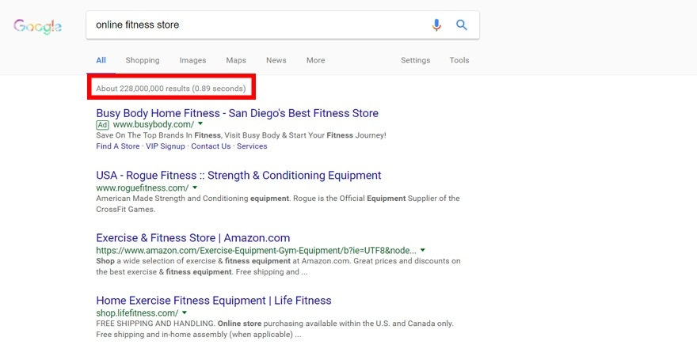**#1: No One Can Buy During a Site Crash**

**Fig.1.1 : No One Can Buy During a Site Crash**

The worst of the ecommerce disadvantages is when no one can buy from your store if your site crashes. That’s why it’s important to ensure your website is hosted on the right platform. For example, if you’re paying the minimum hosting fee and get a surge in traffic from a high converting ad or a television shout-out like Shark Tank, your site will likely crash.

Fortunately, ecommerce solutions like Shopify offer free hosting in their monthly fee, allowing you to have one of the best servers on the market. In recent memory, there was only one time where sites were down. However, ecommerce stores weren’t the only sites affected. Twitter, Spotify, Soundcloud, and more were affected by this crash. The issue was resolved the same day. Yet, site crashes on platforms like Shopify are so rare that it’s likely not to cause problems in your business.

**#2: Customers Can’t Try Before They Buy**

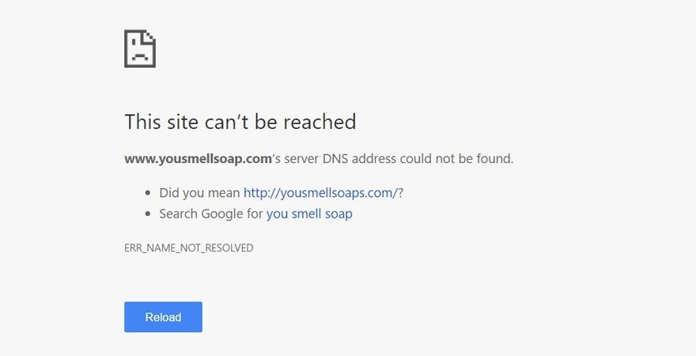**#3: Ecommerce Is Highly Competitive**

Battling for customers is another one of the worst ecommerce disadvantages. The reality is the best niches are often the most competitive. That’s why so many entrepreneurs are drawn to them. However, the more competitive a niche is, the more expensive ads for that niche are. There are a couple of ways around this. First, you can execute a different marketing strategy than your competitors.

If all your customers are being targeted by competitors through Facebook ads, you might try ranking organically with SEO optimization. If all your competitors are using Pinterest, you might try Instagram marketing if your audience is very visual. Second, if your ads are expensive, you can send traffic to blog posts and retarget your customers who visit them to create lower-cost ads. Working on CRO campaigns can help you be much more successful than your customers.

**Ecommerce Disadvantages**

**#4: Customers Can Be Impatient**

If a customer has a question in store a salesperson is on the floor ready to answer them. However, an ecommerce disadvantage is that most businesses experience a delay responding to customer inquiries. The reality is most customers expect a response from a business within the hour on social media. If you delay in responding to their message, they can become angry and shop somewhere else instead. You need to be online 24/7.

**#5: Shipping Times Can Be Lengthy**

Customers consider shipping times to be one of the worst ecommerce disadvantages. When a customer shops in person, she can take the product home right away. But, with online shopping, most customers receive their products in a week or more.

Although Amazon offers same-day shipping, it wasn’t a profitable model until they created Amazon Prime. It only became profitable because they have tens of millions of Prime members. The solution is to be transparent with your customer. Let them know when they can expect packages when they place an order.

* 1. **Services provided by the System:-**

### Create a dashboard for each vendor:-

This would allow them to manage their profile page info, product listings, payment methods, and rates, shipping info, and extract personalized reports that can improve their sales performance and thus the performance of your marketplace.

### Track inventory in real-time

Make it easy for sellers to [manage their inventory](https://www.coredna.com/blogs/inventory-management-strategies) on ANAQA.

### Enable traffic and conversion analytics

Enabling traffic analytics for vendors lets them know where their customers come from and understand what’s helping them convert customer

### Include multiple payment gateways

Customers need multiple ways to pay. ANAQA marketplace support this and provide them with options to pay using major credit cards, PayPal, Cash on Delivery or another popular payment method.

### Provide a powerful and flexible search functionality

**Personalization and product recommendations.**

Anaqa site can track visitors' browse, search and purchase history. They can use this data to present useful and personalized product recommendations, and obtain valuable insights about target markets. Examples include the sections of Amazon product pages labeled "Frequently bought together" and "Customers who viewed this item also viewed."

**Availability.**

Aside from outages or scheduled maintenance, e-commerce sites are available [24x7](https://whatis.techtarget.com/definition/24x7-24-hours-a-day-7-days-a-week), allowing visitors to browse and shop at any time. Brick-and-mortar businesses tend to open for a fixed number of hours and may even close entirely on certain days.

**Easy accessibility.**

Customers shopping a physical store may have a hard time determining which aisle a particular product is in. In Anaqa, visitors can browse product category pages and use the site search feature the find the product immediately.

**Lower cost.**

pure play e-commerce businesses avoid the cost associated with physical stores, such as rent, inventory and cashiers, although they may incur shipping and warehouse costs.

**Provide UGC and social media integration for each vendor.**

* 1. **Background Information: -**

E‐commerce technologies provide effective and efficient ways in which corporate buyers can gather information rapidly about available products, evaluate and negotiate with suppliers, implement order fulfillment over communications links, and access post‐sales services. (For Customers preview) they can start looking for products/items through scrolling on the pages or using the search bar with the help of filters for faster results. Then they need to register/login to grant access for more services, like Wishlist to save the products they would like to purchase, they can also compare between two or more products before they add it to the Cart. After adding the products/items to the Cart they can finally order/purchase it, to complete the order they have to fill some information including (address, phone number,..etc.) then choose the payment method they would like to pay with. If there any issues while ordering they can contact the support/admin.(For Vendors preview) they have to register/login to grant access for more services, like adding/removing products/items after that they have to wait for admin permission to publish their products and the merchant for the final price after taxes. If there any issues while publishing or removing any product they can contact the support/admin.

**1.4 Problem Statement:-**

**A shop Site is a specific form of displaying certain products in specific formats and forms. Which provides the buying and selling process, including the primary market, online stores, and some electronic stores for commercial organizations, shops selling products, shops buying products, and shops exchanging goods and products with each other. It's very important to be able to respond to client needs in a more effective and timely manner. If your customers wish to see your business online and have instant access to your products or services. Today online shopping (E-commerce) is a lifestyle, which retails various fashion and lifestyle products (Currently Men’s and Women`s Wear). In this project customers are allowed to view various products available, enabled to be registered to purchase desired products instantly using the payment method (Instant Pay) and also can place orders by using the Cash on Delivery (Paying Later) option and multi-Language. Designing a multi-vendor online store is one of the most important steps in increasing profits through e-commerce, especially after the impact of the Corona Virus on E-commerce. Ease and ease of use to increase sales movement from anywhere and at any time. So that each vendor has a panel to add his products and follow up on his requests but the site is shared to display all products together and customers matching his outfit easily. The Recommendation system, I have designed below is based on the journey of a new customer from the time he/she lands on the business’s website for the first time to when he/she makes repeat purchases. By using Algorithms in The recommendation system is designed in three parts based on the business context:-**

**- Recommendation system part I:**

**Product popularity-based system targeted at new customers.**

**- Recommendation system part II:**

**Model-based collaborative filtering system based on customer's**

**purchase history and ratings provided by other users who bought**

**items similar items.**

**- Recommendation system part III:**

**When a business is setting up its e-commerce website for the first time**

**without any product, rating When a new customer without any previous**

**purchase history visits the e-commerce website for the first time, he/she is recommended the most popular products sold on the shop website.**

**Chapter 2**

**Theoretical Background and Tools**

**2.1 The Front-End**

The part of a website that the user interacts with directly is termed the front end. It is also referred to as the ‘client side’ of the application. It includes everything that users experience directly: text colors and styles, images, graphs and tables, buttons, colors, and navigation menu. HTML, CSS, and JavaScript are the languages used for Front End development. The structure, design, behavior, and content of everything seen on browser screens when websites, web applications, or mobile apps are opened up, is implemented by front End developers. Responsiveness and performance are two main objectives of the Front End. The developer must ensure that the site is responsive i.e. it appears correctly on devices of all sizes no part of the website should behave abnormally irrespective of the size of the screen.

**Front end Languages:** The front-end portion is built by using some languages which are discussed below: 

**2.1.1 HTML**

HTML stands for Hypertext Markup Language. It is used to design the front-end portion of web pages using a markup language. HTML is the combination of Hypertext and Markup language. Hypertext defines the link between the web pages. The markup language is used to define the text documentation within the tag which defines the structure of web pages.

**2.1.1.2 Advantages of HTML?**

1. HTML is widely used.
2. Every browser supports HTML Language.
3. Easy to learn and use.
4. HTML is light weighted and fast to load
5. Do not get to purchase any extra software because it’s by default in every window
6. Easy to use
7. Loose syntax (although, being too flexible won’t suit standards).
8. HTML is that it is easy to code even for novice programmers.
9. HTML also allows the utilization of templates, which makes designing a webpage easy.

10) Free – You need not buy any software.

**2.1.1.3 Disadvantages of HTML?**

1. It cannot produce dynamic output alone, since it’s a static language
2. Making the structure of HTML documents becomes tough to understand
3. Errors can be costly
4. It is the time consuming as the time it consume to maintain on the colour scheme of a page and to make lists, tables and forms
5. It can create only static and plain pages so if we’d like dynamic pages then HTML isn’t useful.
6. Required to write a lot of code for just creating a simple webpage
7. We have to check up the deprecated tags and confirm not to use them to appear because another language that works with HTML has replaced the first work of the tag, and hence the opposite language needs to be understood and learned.
8. Security features offered by HTML are limited.
9. If we need to write down long code for creating a webpage then it produces some complexity.
10. HTML can create only static and plain pages so if we’d like dynamic pages then HTML isn’t useful.

**2.1.2 CSS**

Cascading Style Sheets fondly referred to as CSS is a simply designed language intended to simplify the process of making web pages presentable. CSS allows you to apply styles to web pages. More importantly, CSS enables you to do this independent of the HTML that makes up each web page.

**2.1.2.1 Advantages of CSS?**

1. CSS plays an important role, by using CSS you simply got to specify a repeated style for element once & use it multiple times as because CSS will automatically apply the required styles
2. The main advantage of CSS is that style is applied consistently across variety of sites. One instruction can control several areas which is advantageous.
3. Web designers needs to use few lines of programming for every page improving site speed.
4. Cascading sheet not only simplifies website development, but also simplifies the maintenance as a change of one line of code affects the whole web site and maintenance time.
5. It is less complex therefore the effort are significantly reduced.
6. It helps to form spontaneous and consistent changes.
7. CSS changes are device friendly. With people employing a batch of various range of smart devices to access websites over the web, there’s a requirement for responsive web design.
8. It has the power for re-positioning. It helps us to determine the changes within the position of web elements who are there on the page.
9. These bandwidth savings are substantial figures of insignificant tags that are indistinct from a mess of pages.

10. Easy for the user to customize the online page

**2.1.2.2 Disadvantages of CSS?**

1. CSS, CSS 1 up to CSS3, result in creating of confusion among  web browsers.
2. CSS, CSS 1 up to CSS3, result in creating of confusion among  web browsers.
3. There exists a scarcity of security.
4. After making the changes we need to confirm the compatibility if they appear. The similar change affects on all the browsers.
5. The programing language world is complicated for non-developers and beginners. Different levels of CSS i.e. CSS, CSS 2, CSS 3 are often quite confusing.
6. Browser compatibility (some styles sheet are supported and some are not).
7. CSS works differently on different browsers. IE and Opera supports CSS as different logic.
8. There might be cross-browser issues while using CSS.

**2.1.3 Bootstrap?**

is a free and open-source CSS framework directed at responsive, mobile-first front-end web development. It contains CSS and (optionally) JavaScript-based design templates for typography, forms, buttons, navigation, and other interface components.

**2.1.3.1 why Bootstrap?**

After its open source release in 2011, Bootstrap became popular very quickly, and not without reason. Web designers and web developers like Bootstrap because it is flexible and easy to work with. Its main advantages are that it is responsive by design, it maintains wide browser compatibility, it offers consistent design by using re-usable components, and it is very easy to use and quick to learn. It offers rich extensibility using JavaScript, coming with built-in support for jQuery plugins and a programmatic JavaScript API. Bootstrap can be used with any IDE or editor, and any server side technology and language, from ASP.NET to PHP to Ruby on Rails.

With Bootstrap, web developers can concentrate on the development work, without worrying about design, and get a good looking website up and running quickly. Conversely, it gives web designers a solid foundation for creating interesting Bootstrap themes.

* + - 1. **Advantages of Bootstrap?**

1. Fewer Cross browser bugs.
2. A consistent framework that supports major of all browsers and CSS compatibility fixes.
3. Lightweight and customizable.
4. Responsive structures and styles.
5. Several JavaScript plugins using the jQuery.
6. Good documentation and community support.
7. Loads of free and professional templates, WordPress themes and plugins.

**2.1.3.3 Disadvantages of Bootstrap?**

1. There will be requirement of lots of style overrides or rewriting files that can thus lead to a lot of time spent on designing and coding the website if the design tends to deviate from the customary design used in Bootstrap.
2. You would have to go the extra mile while creating a design otherwise all the websites will look the same if you don’t do heavy customization.
3. Styles are verbose and can lead to lots of output in HTML which is not needed.
4. JavaScript is tied to jQuery and is one of the commonest library which thus leaves most of the plugins unused.
5. Non-compliant HTML.

**2.2 What is Backend?**

Users interact directly with clients such as websites or mobile apps. These clients then send requests over the network to servers, which are programs that are running on some machine somewhere in the world. the server-side development. It focuses on databases, scripting, website architecture. It contains behind-the-scene activities that occur when performing any action on a website. It can be an account login or making a purchase from an online store. Code written by back-end developers helps browsers to communicate with database information Most common example of Backend programming is when you are reading an article on the blog. The fonts, colors, designs, etc. constitute the frontend of this page. While the content of the article is rendered from a server and fetched from a Database . This is the backend part of the application.

**What is a server?**

A server is a computer that listens for incoming requests. Though there are machines made and optimized for this particular purpose, any computer that is connected to a network can act as a server. In fact, you will often use your very own computer as server when developing apps.

**2.2.1 PHP?**

PHP (recursive acronym for PHP: Hypertext Preprocessor) is a widely-used open source general-purpose scripting language that is especially suited for web development and can be embedded into HTML.

**2.2.1.1 Why PHP?**

It’s easy to learn and use: One of the main reasons PHP became so commonplace is that it is relatively simple to get started with. Even without extensive knowledge or experience in web development, most people could create a web page with a single PHP file in a relatively short period of time. The syntax is simple and command functions are easy to learn, meaning the barriers to entry with PHP are lower than with many other languages. It’s open source (and therefore free!): This also helps developers get started with PHP - it can be installed quickly and at zero cost. There is also open access to a wide range of PHP frameworks, such as Laravel and Symfony. This feature is also

appealing to companies as it helps control the costs of web development.

It’s versatile: One of the major benefits of PHP is that it is platform independent, meaning it can be used on Mac OS, Windows, Linux and supports most web browsers. It also supports all the major web servers, making it easy to deploy on different systems and platforms at minimal additional cost.

It enjoys strong community support: As a veteran scripting language that is widely used, PHP now has a large and loyal community base to support it. There are tons of tutorials, FAQs, and tips to help new PHP developers and to continue pushing the boundaries of what the language can achieve through regular updates.

It is well connected with databases: PHP makes it easy to connect securely with almost any kind of database. This gives developers more freedom when choosing which database is best suited for the application being built.

**2.2.1.2 Advantages of php?**

1. Most important advantage of PHP is that it’s open source and free from cost. It can be downloaded at anywhere and readily available to use for event of web applications.
2. It is platform independent. PHP based applications can run on any OS like UNIX, Linux and Windows, etc.
3. Application can easily be loaded which are based on PHP and connected to database. It’s mainly used due to its faster rate of loading over slow internet speed than another programming language.
4. It has less learning curve, because it is simple and straightforward to use. Someone familiar with C programming can easily work on PHP.
5. It is more stable from a few years with assistance of providing continuous support to various versions.
6. It helps in reusing an equivalent code and no got to write lengthy code and sophisticated structure for event of web applications.
7. It helps in managing code easily.
8. It has powerful library support to use various function modules for data representation.
9. PHP’s built-in database connection modules help in connecting database easily reduce trouble and time for development of web applications and content based sites.
10. Popularity of PHP gave rise to various community of developers, a fraction of which may be potential candidates for hire.
11. Flexibility makes PHP ready to effectively combine with many other programming languages in order that the software package could use foremost effective technology for every particular feature.

**2.2.1.3 Disadvantages of php?**

1. It is not that secure due to its open-source, because the ASCII text file are often easily available.
2. It is not suitable for giant content-based web applications.
3. It has a weak type, which can cause incorrect data and knowledge to user.
4. PHP frameworks got to learn to use PHP built-in functionalities to avoid writing additional code.
5. Using more features of PHP framework and tools cause poor performance of online applications.
6. PHP don’t allow change or modification in core behavior of online applications.
7. The PHP frameworks aren’t equivalent in behavior so does their performance and features.
8. While PHP may be a powerful tool supported by an outsized community and plentiful reference documentation, there are easier programming languages for web apps.
9. It is widely believed by the developers that PHP features a poor quality of handling errors. PHP lacks debugging tools, which are needed to look for errors and warnings. PHP has less number of debugging tools in comparison to other programming languages.
10. It’s highly tough to manage because, it’s not competent modular. It already imitates the features of Java language.

**2.2.2 Laravel**

Laravel is a web application framework with expressive, elegant syntax. A web framework provides a structure and starting point for creating your application, allowing you to focus on creating something amazing while we sweat the details.

Laravel strives to provide an amazing developer experience while providing powerful features such as thorough dependency injection, an expressive database abstraction layer, queues and scheduled jobs, unit and integration testing, and more.

Whether you are new to PHP or web frameworks or have years of experience, Laravel is a framework that can grow with you. We'll help you take your first steps as a web developer or give you a boost as you take your expertise to the next level. We can't wait to see what you build.

**2.2.2.1 why Laravel?**

There are a variety of tools and frameworks available to you when building a web application. However, we believe Laravel is the best choice for building modern, full-stack web applications.

A Progressive Framework

We like to call Laravel a "progressive" framework. By that, we mean that Laravel grows with you. If you're just taking your first steps into web development, Laravel's vast library of documentation, guides, and video tutorials will help you learn the ropes without becoming overwhelmed.

If you're a senior developer, Laravel gives you robust tools for dependency injection, unit testing, queues, real-time events, and more. Laravel is fine-tuned for building professional web applications and ready to handle enterprise work loads.

A Scalable Framework

Laravel is incredibly scalable. Thanks to the scaling-friendly nature of PHP and Laravel's built-in support for fast, distributed cache systems like Redis, horizontal scaling with Laravel is a breeze. In fact, Laravel applications have been easily scaled to handle hundreds of millions of requests per month.

Need extreme scaling? Platforms like Laravel Vapor allow you to run your Laravel application at nearly limitless scale on AWS's latest serverless technology.

A Community Framework

Laravel combines the best packages in the PHP ecosystem to offer the most robust and developer friendly framework available. In addition, thousands of talented developers from around the world have contributed to the framework. Who knows, maybe you'll even become a Laravel contributor.

**2.2.2.2 Advantages of Laravel?**

**1. New features of PHP can be used**

The biggest advantage of the Laravel framework over the others is that it utilizes all the new features of the PHP. Most of the other frameworks are unable to do it. By using the Laravel 5, you are able to use many new features that are provided by PHP like Interfaces, overloading, Shorter array syntax, Namespaces, Anonymous functions.

**2. Great documentation**

It is believed that Laravel is develop-friendly due to documentation. All the version of the Laravel is discharged with the proper documentation in which you are able to find good and detailed explanations of classes, coding style, methods.

**3. Integration with mail services**

It is very compulsory for web applications to stay in touch with the users and inform them about the new deals and offers. The framework is equipped with API rather than the Swift Mailer library. It also provides the drivers SMTP, Mail gun, Spark Post, Mandrill, PHP’s “mail” function, Amazon SES, and “send email” which helps you in sending the emails through the local services or cloud-based.

**4. Supports popular cache backends**

One of the more adventitious features is that it supports Memcached and Redis out-of-the-box.

**5. Artisan**

It is very difficult to do the repetitive programming tasks which are heavily time-consuming. Artisan is the command-line tool that helps in creating the skeleton code and runs the database system strongly.

**6. Packages and resource availability**

You can take advantage of npm packages and bower packages by connecting the framework with elixir and Gulp. It is very beneficially in resource and asset revisioning. Moreover, this combined with the composer will sort out dependencies and therefore it is the most stable source of the package in the PHP world.

**7. A reduced product development cycle**

As the integrations are faster it is possible to reduce the product development cycle. Also, you are provided with huge community support and have the assistance of Lara casts.

**8. IoC Container**

IoC is referred to as the inversion of Control. It is used for generating new objects without bootstrap any external libraries. Simply put, you are able to access these objects from where you are coding, you don't need to deal with inflexible monolithic structures.

**9. Reverse Routing**

It is also the most beautiful feature of Laravel. In this, you are able to create links to named routes. It is very easy for the users to create the links, just simply use the route's name, and the framework will automatically insert the correct URL. If the user changes the route, the change will occur everywhere.

**10. Active Record Implementation**

This is one of the most useful features in the framework in which it gives an easy and very helpful Active Record implementation for running with your database. Put differently, it intends that the models you build in the MVC will have a corresponding table in the database.

**2.2.2.2 Disadvantages of Laravel?**

**1. The Composer is not strong enough**

As Laravel is a new framework, therefore it is difficult for developers to deal with it. Also, the composer of Laravel is not strong enough in comparison with Ruby gems, npm (node.js), pip (for python), etc.

**2. Lack of continuation between versions**

No transition from Laravel 4 to 5 has seemed. It could break the application if you try to update the code.

**3. Quality is mixed at times**

There are some components in the framework which are not well-designed.

For instance, sometimes dependency injection becomes needlessly complex. You have to learn a lot before you start to create applications.

Therefore, it is not suitable for amateur developers.

**4. Some upgrades might be problematic**

It is not only a Laravel problem but also PHP frameworks that show some troubles when the version is upgraded. So, the user has to take care of the precautions before updating the version.

**5. Development**

If we check the development of other frameworks, we found out that their development is quite faster in contrast with Laravel.

**2.3 Database?**

A database is an organized collection of structured information, or data, typically stored electronically in a computer system. A database is usually controlled by a database management system (DBMS). Together, the data and the DBMS, along with the applications that are associated with them, are referred to as a database system, often shortened to just database. Data within the most common types of databases in operation today is typically modeled in rows and columns in a series of tables to make processing and data querying efficient. The data can then be easily accessed, managed, modified, updated, controlled, and organized. Most databases use structured query language (SQL) for writing and querying data.

**2.3.1 MySQL?**

### A database is a structured collection of data. It may be anything from a simple shopping list to a picture gallery or the vast amounts of information in a corporate network. To add, access, and process data stored in a computer database, you need a database management system such as MySQL Server. Since computers are very good at handling large amounts of data, database management systems play a central role in computing, as standalone utilities, or as parts of other applications.

**2.3.2 why MySQL?**

* Scalability and Flexibility

### The MySQL database server provides the ultimate in scalability, sporting the capacity to handle deeply embedded applications with a footprint of only 1MB to running massive data warehouses holding terabytes of information. Platform flexibility is a stalwart feature of MySQL with all flavors of Linux, UNIX, and Windows being supported. And, of course, the open source nature of MySQL allows complete customization for those wanting to add unique requirements to the database serve

* High Performance

A unique storage-engine architecture allows database professionals to configure the MySQL database server specifically for particular applications, with the end result being amazing performance results. Whether the intended application is a high-speed transactional processing system or a high-volume web site that services a billion queries a day, MySQL can meet the most demanding performance expectations of any system. With high-speed load utilities, distinctive memory caches, full text indexes, and other performance-enhancing mechanisms, MySQL offers all the right ammunition for today's critical business systems.

* **High Availability**

Rock-solid reliability and constant availability are hallmarks of MySQL, with customers relying on MySQL to guarantee around-the-clock uptime. MySQL offers a variety of high-availability options from high-speed master/slave replication configurations, to specialized Cluster servers offering instant failover, to third party vendors offering unique high-availability solutions for the MySQL database server

**Robust Transactional Support**

MySQL offers one of the most powerful transactional database engines on the market. Features include complete ACID (atomic, consistent, isolated, durable) transaction support, unlimited row-level locking, distributed transaction capability, and multi-version transaction support where readers never block writers and vice-versa. Full data integrity is also assured through server-enforced referential integrity, specialized transaction isolation levels, and instant deadlock detection.

**Web and Data Warehouse Strengths**

MySQL is the de-facto standard for high-traffic web sites because of its high-performance query engine, tremendously fast data insert capability, and strong support for specialized web functions like fast full text searches. These same strengths also apply to data warehousing environments where MySQL scales up into the terabyte range for either single servers or scale-out architectures. Other features like main memory tables, B-tree and hash indexes, and compressed archive tables that reduce storage requirements by up to eighty-percent make MySQL a strong standout for both web and business intelligence applications.

**Chapter 3**

**System Analysis & Design**

**1.System Analysis:-**

**1.1.Software Requirement Specifications (SRS):-**

**1.1.1.Purpose :**

It will enable vendors to setup online shops, customer to browse through the shop and purchase them online without having to visit the shop physically. The administration module will enable a system administrator to approve and reject requests for new shops and maintain various lists of shop category.

**1.1.2.Project Scope :**

It is required to be programmed as a website as a special programming. It is very responsive with all devices as (Smart Mobile phones, PCs, laptops) and all operating systems as (Windows, IOS, Android).

**1.1.3.Functional****Requirements** :-

**1.1.3.1.Registration**:

If customer wants to buy the product, then he/she must be registered, unregistered user can’t order the products that in the shopping cart.

**1.1.3.2.Login**:

Customer logins to the system by entering valid user id and password for theshopping.

**1.1.3.3.Changes to Cart:**

Changes to cart means the customer after login or registration can makeorder or cancel order of the product from the shopping cart.

**1.1.3.4.Payment**:

Customer after order products must select the way to payment

(cash, card) to conform the order.

**1.1.3.5.Logout:**

Customer can logout from the site in any time.

**1.1.3.6.Report Generation:**

After ordering for the product, the system will send one copy of the bill to the customer’s Email-address and another one for the system data base.

**1.1.3.7.Wishlist:**

Changes to wish-list means the customer after login or registration can add/remove the product to/from the wish-list.

**1.1.4.Non-Functional Requirements:**

**Following Non-Functional Requirements will be there in the insurance to the internet:**

* + - 1. Secure access to consumer’s confidential data.
      2. 24X7 availability.
      3. Better component design to get better performance at peak time.
      4. Flexible service-based architecture will be highly desirable for future extension. Non-Functional Requirements define system properties and constraints.

**1.1.5.Performance** **Requirements:**

In order to maintain an acceptable speed at maximum number of uploads allowed from a particular customer as any number of users can access to the system at any time. Also, the connections to the servers will be based on the attributes of the user like his location and server will be working 24X7 times.

**1.1.6.Interface Requirement:**

**Various interfaces for the product could be:**

* + - 1. Login Page
      2. Registration Form
      3. There will be a screen displaying information about product that the shop having.
      4. If the customers select the buy button, then another screen of shopping cart will be opened.
      5. After ordering for the product, the system will send one copy of the bill to the customer’s Email address.

**1.1.7.Software Interface:**

All Operating Systems: Aneroid, iOS, windows, …etc.

**1.1.8.Hardware Interface:**

Smartphones, PC, Tablet, …etc.

**2.System Design:-**

**2.1.ER Diagram:-**

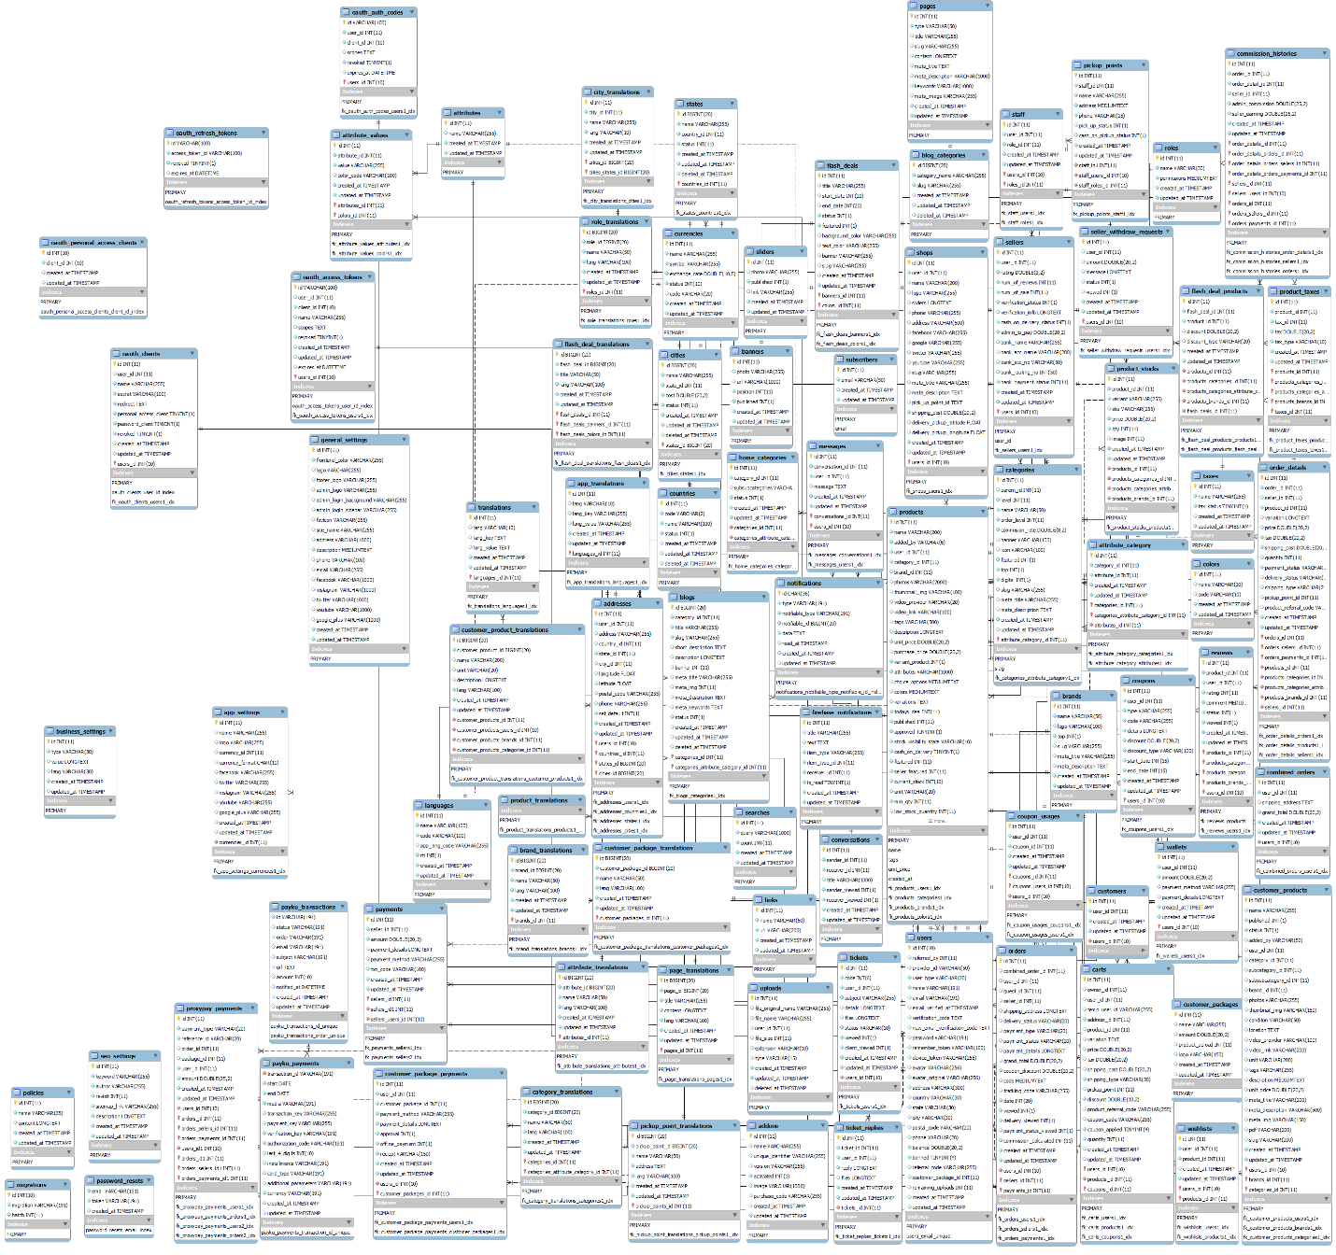

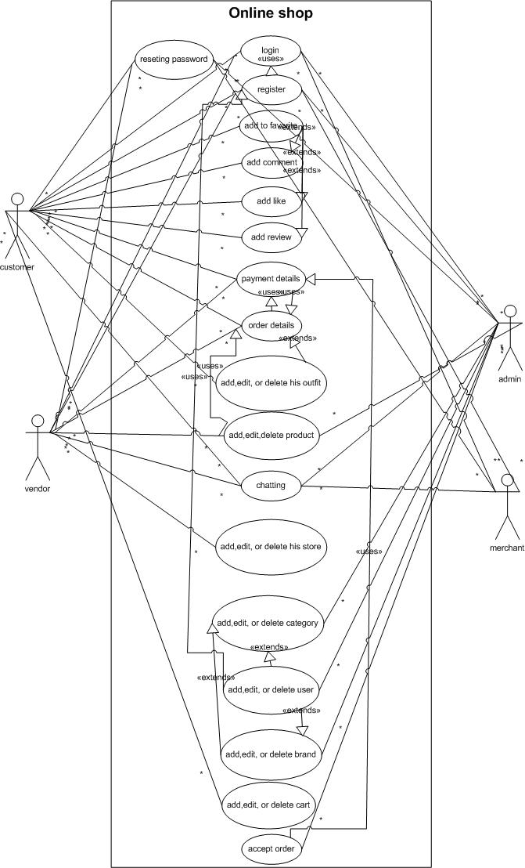**2.2.Use Case** :-

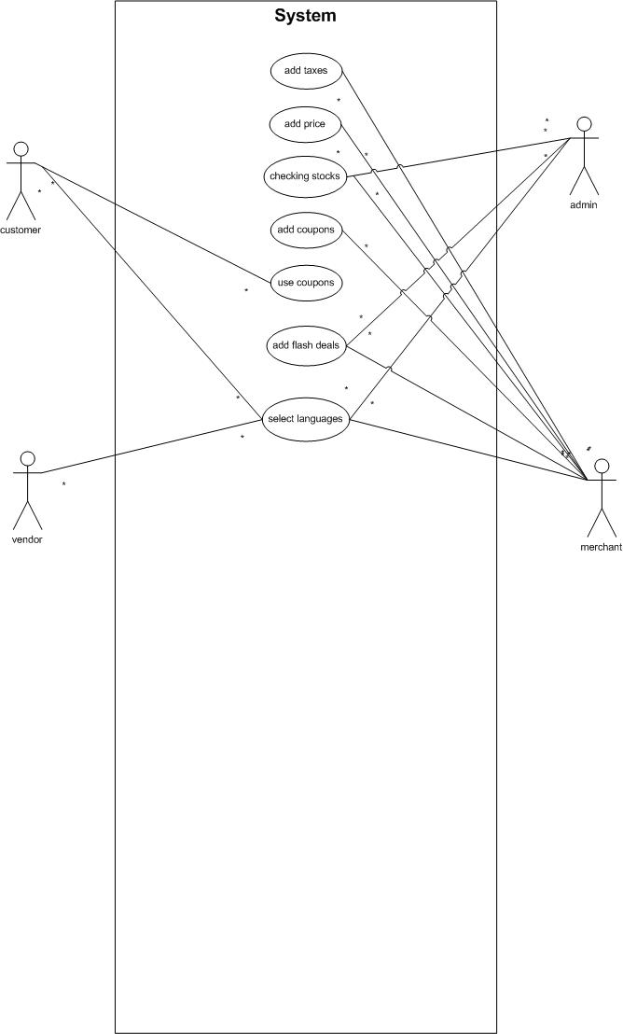

**2.3.Sequence Diagram:-**

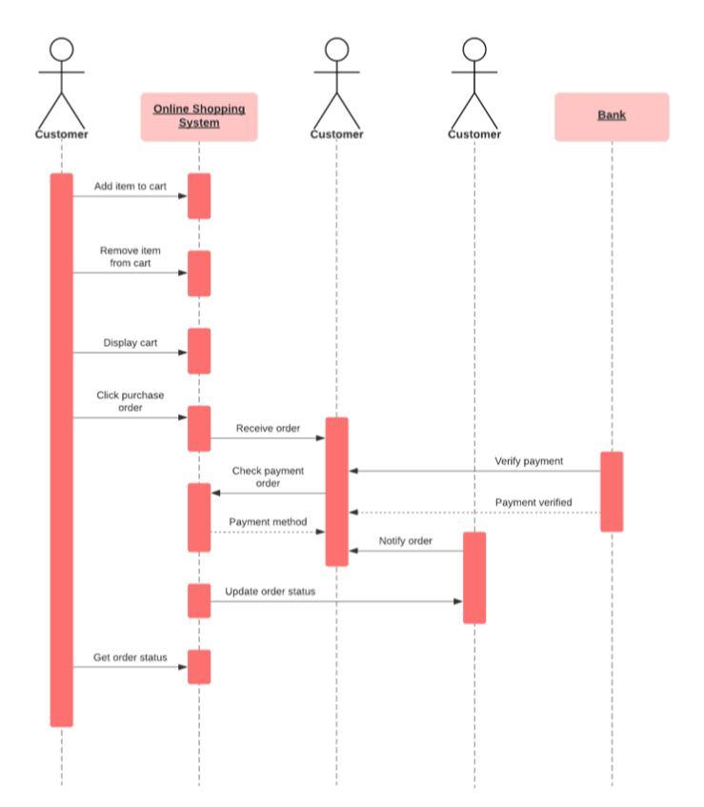

**2.4.Activity Diagram:-**

This article explain about user and admin work flow features with diagrams

user login:-

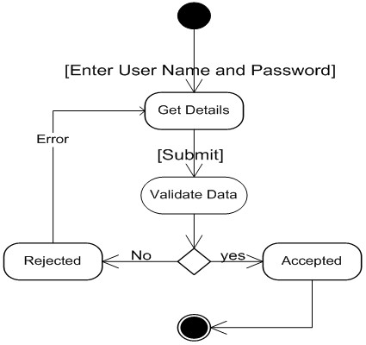The below attached User of the shopping cart system activity diagram explains about how login activity of user and admin works, Here user enters user name and password in the login web form and system validates the user details with the database, if the user details are equal to the database details then it can accept the user login form and proceeding to the next level or else it can reject the user login.

Admin registration:-

Here user enters total details like user name, password and personal details then click on the sign in button, where inner code validate the details entered by user, it is basically works with client side scripting language java script and finally accept the user registration process.

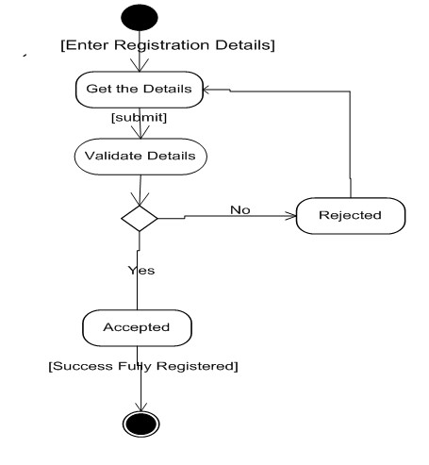

admin username and password validation

The below attached Admin Activity Diagram explains admin username and password validation, managing user orders, manage new product details, data processing methods, accepting money payments, user and group permissions, etc.

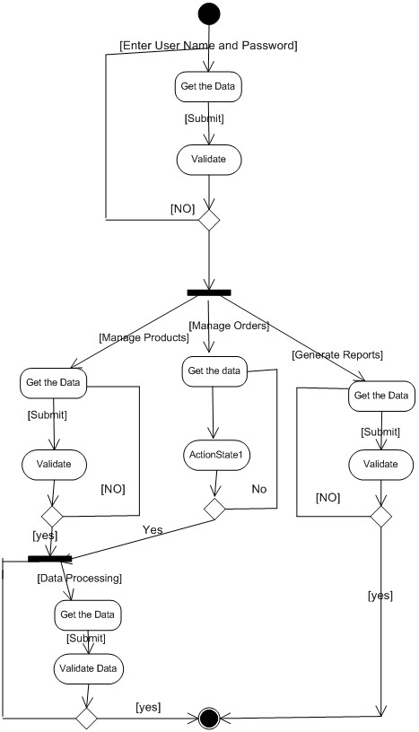

user product details, ordering products, view products

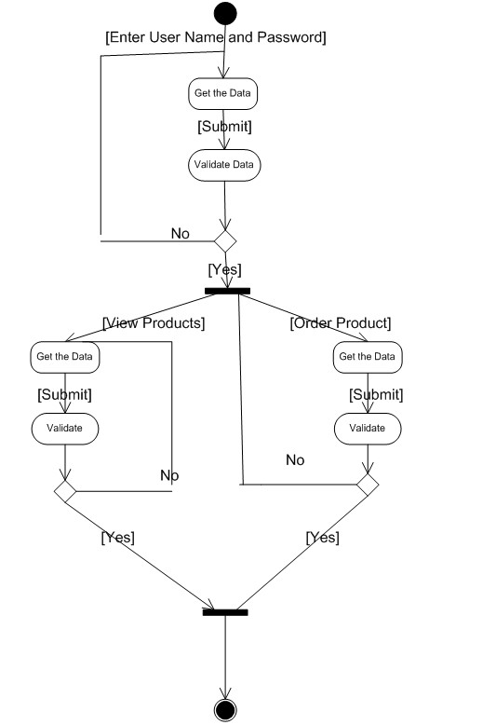

**Chapter 4**

**Chapter 5**